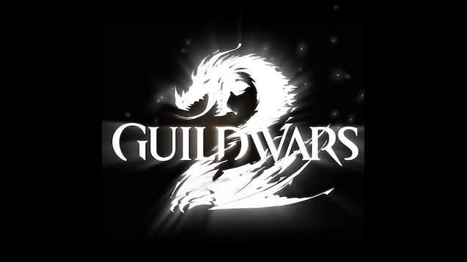

GUILDWARS 2 Commander Guide

Handful things you need to know to become a (good) commander in the game

By Lexa Km Trikru AKA Larissa

Guardian of the united[gotu] (leader)   EU based

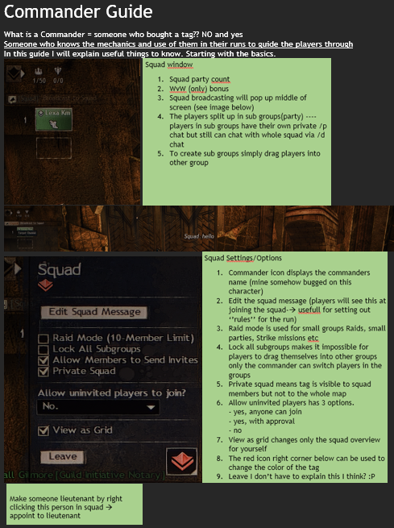

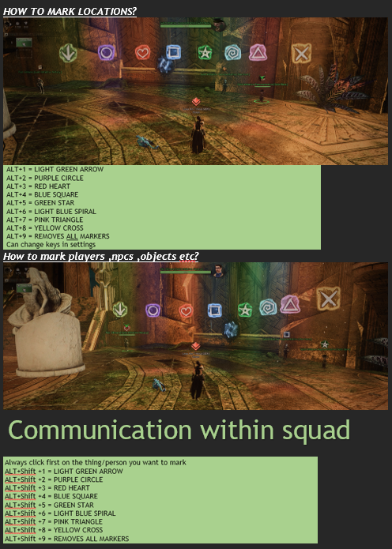

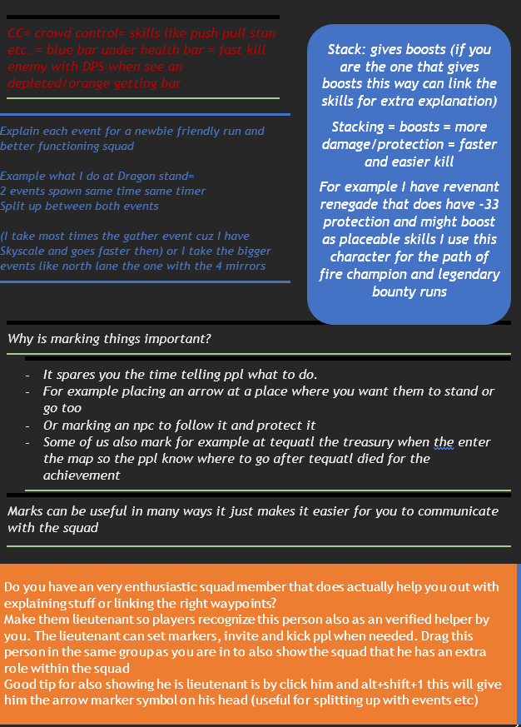

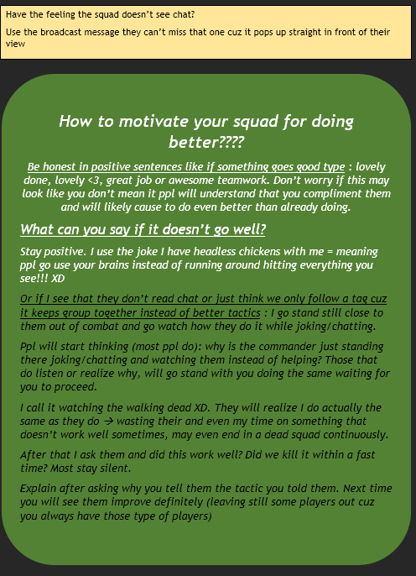

be original with your leading, implement some things that do maybe even describe you a bit. For example I love to talk I am very chatty when I type. Soo I tell things, make jokes, ask for jokes etc. Or I buy lots of tonics share them with squad and go running with tonics(getting brawl achievement) while waiting (sadly gw2 thinks you’re a spammer if you mail ppl the tonics fast after each other XD. soo I stopped that since it made me spend too much time sending mails). If you’re fun to follow, ppl are more willing to participate actively.

for example @Flawless Equinox(Murmaid) makes much jokes ppl love it, that’s his specialty within the motivating part of the squads.

@Coopz(Coopziana) is more direct what he tells you need to do so the progress will go smooth and fast. You can still chat tho but keep serious :P

Everyone has his own style 🡪 try out stuff, find what suits you the best. Be original

**After all being a good commander goes together with trial and error. You cannot get good when you don’t make mistakes. But do learn from those mistakes.**

**Also good to remember🡪 a good commander can only be good if he has a good team. If something fails?**

**It’s also on the team cuz 1 person can’t do all changes he can tell them things but not actually make them do it!!**

**Remember that cuz there are some dicks out there that love to blame the commander for the error of others.**